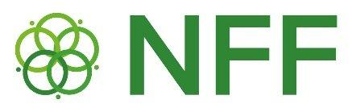

Important adjustments regarding Budget Re-Alignment to Strengthen Localization

- The maximum ceiling per project proposal/ consortium has been changed to USD 2.5 million (from previously USD 2.9 million).
- At the same time, the overall available envelope for successful project ideas in both countries (Cameroon and Chad) was increased from USD 5.8 to 5.9 million.
- Out of this total of USD 5.9 million, 5 million are available for successful project ideas from Cameroon and Chad.
- A dedicated amount of USD 900,000 will be retained to enable local NGOs that participate in Consortia selected for the preparation of full project proposals to request budgets that exceed the indicative ceiling for Local NGOs (USD 150,000) mentioned in the Call for Proposal:
  - In case local NGOs demonstrate that they have the required capacities to manage amounts higher than USD 150,000 as demonstrated in:
    - their existing HACT ratings – as submitted during the concept note stage,
    - the HACT assessment to be commissioned by UNDP for those local NGOs that currently have no HACT assessment but will undergo one in case their consortium will be shortlisted to prepare a full proposal submission.
Once HACT assessments are available (before grants are provided and contracts are signed), UNDP as Fund Manager may authorize an increase of the ceiling in consultation with the NFF Secretariat and with technical guidance from the Independent Technical Review Committee (ITRC), depending on the HACT risk rating.
- These above adjustments were made to allow for maximum flexibility towards achieving localization targets
- Through this measure, the NFF reaffirms its commitment to translating the principle of localization into practice—by not only engaging local actors but also empowering them as key implementers and leaders of sustainable Nexus interventions in the Lake Chad Basin.

